**Laporan Tugas**

**Praktikum Pemrograman Berbasis Website**



**Oleh:**

Nama: Antonius Valentino Dharma Kusuma

NPM: 4522210109

**Dosen:**

Adi Wahyu Pribadi,S.Si.,M.Kom

**S1-Teknik Informatika**

**Fakultas Teknik Universita Pancasila**

**2024/2025**

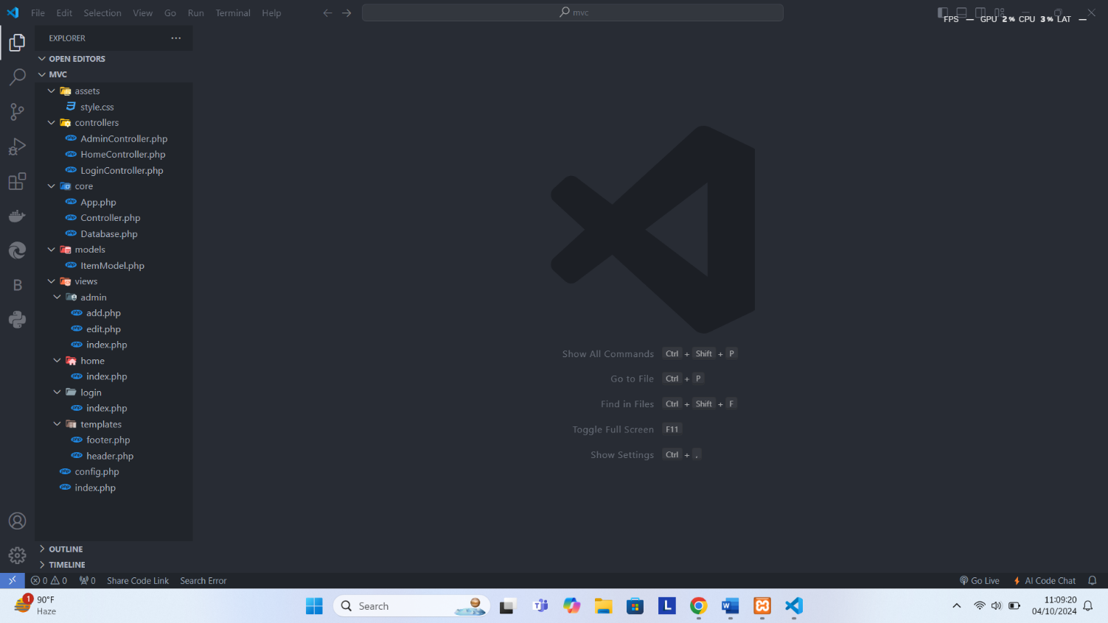Struktur MVC (Models, Views, Controls)

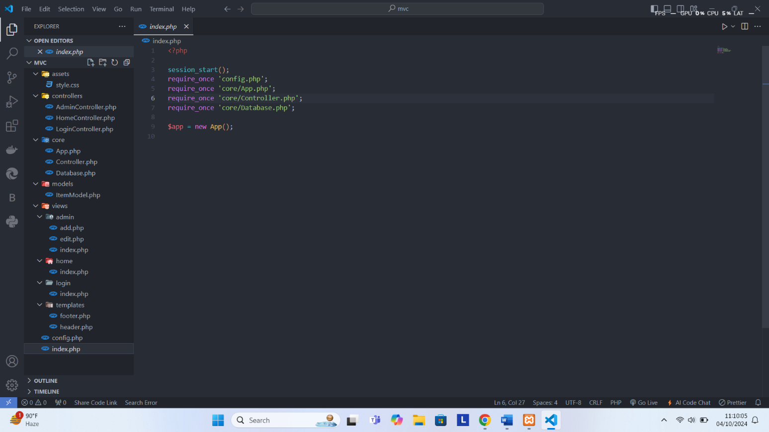Kode index.php

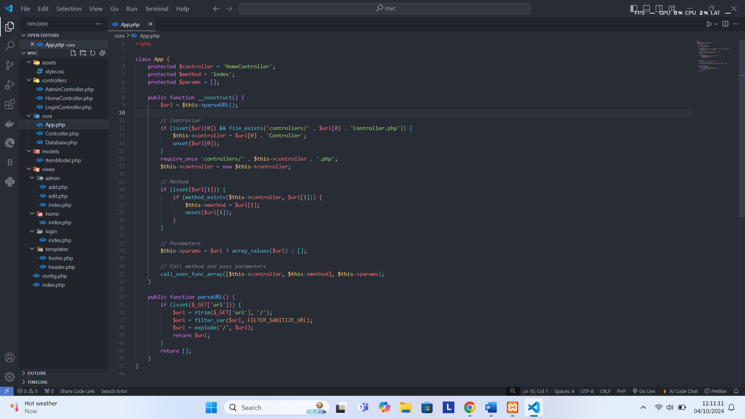Kode core/App.php

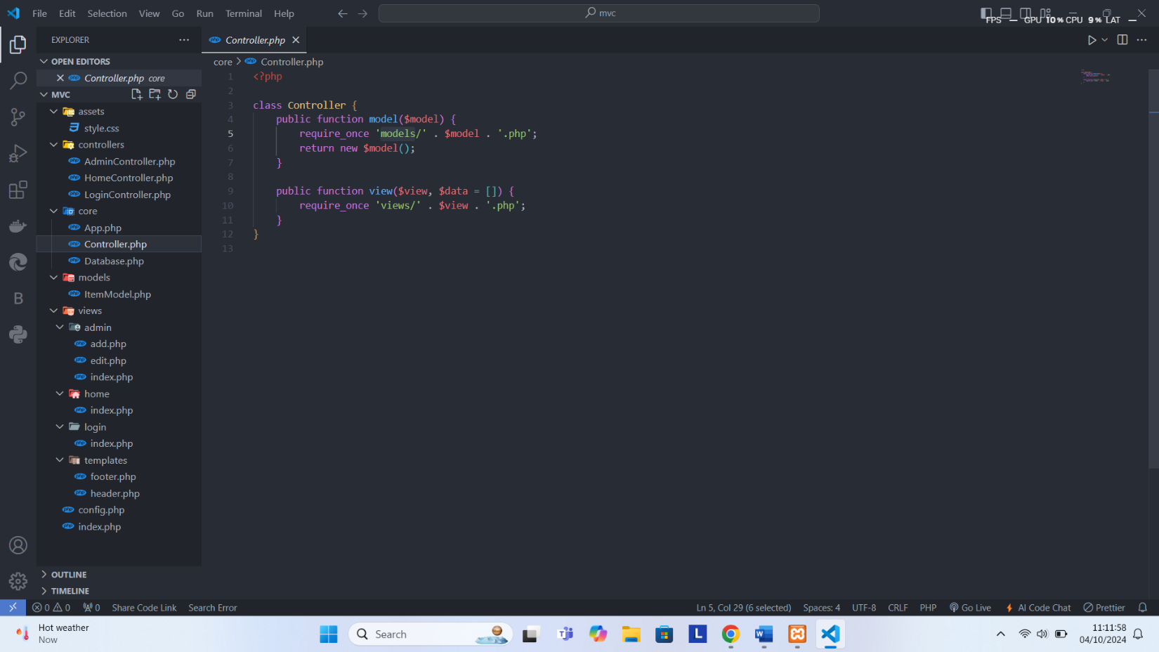Kode core/Controller.php

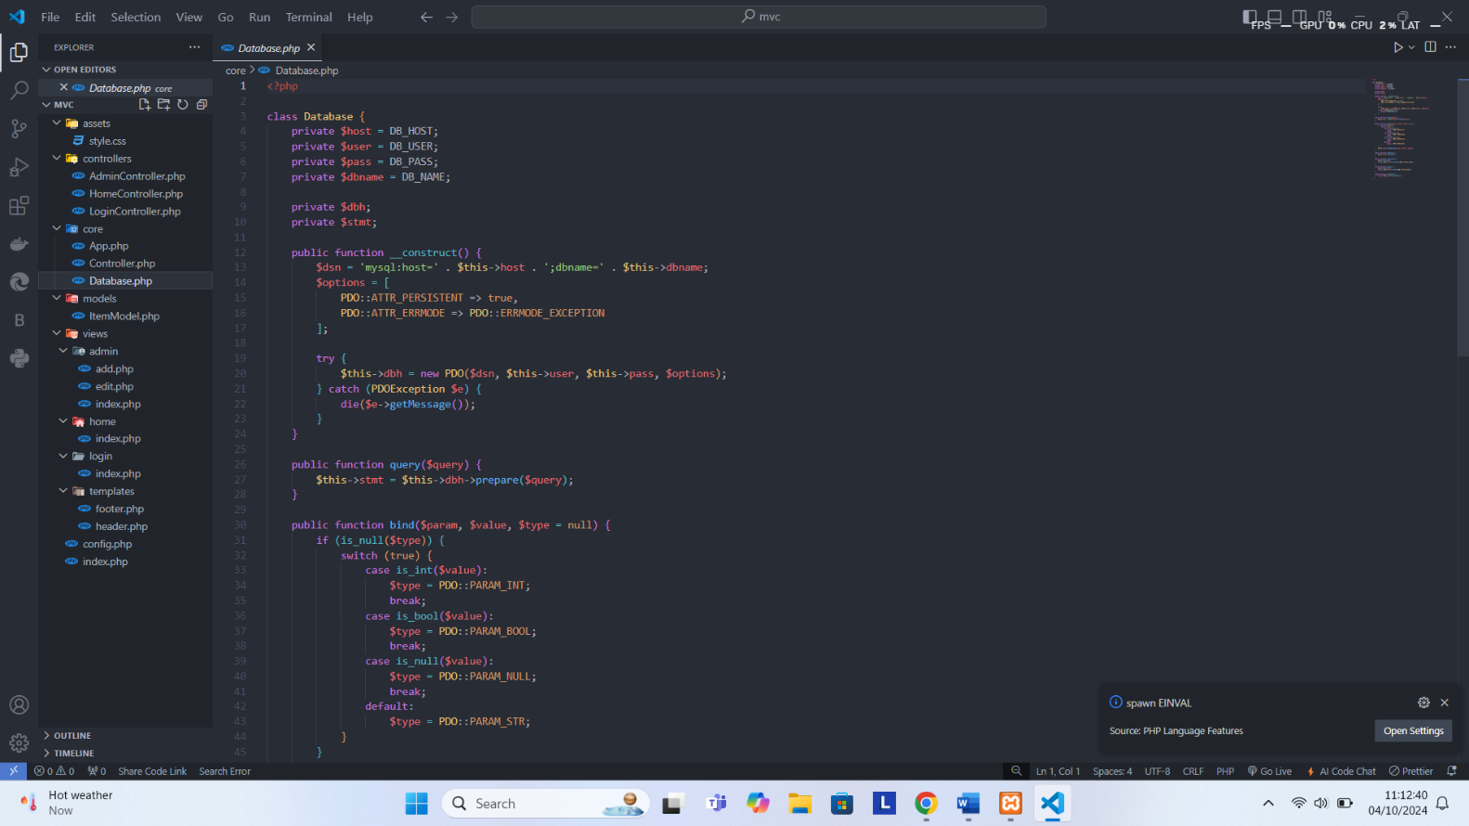Kode core/Database.php

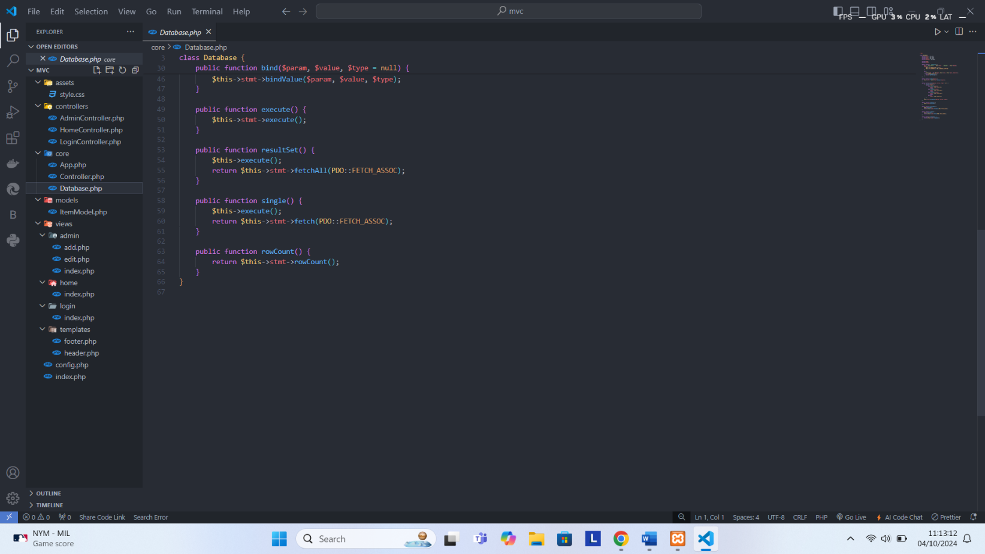

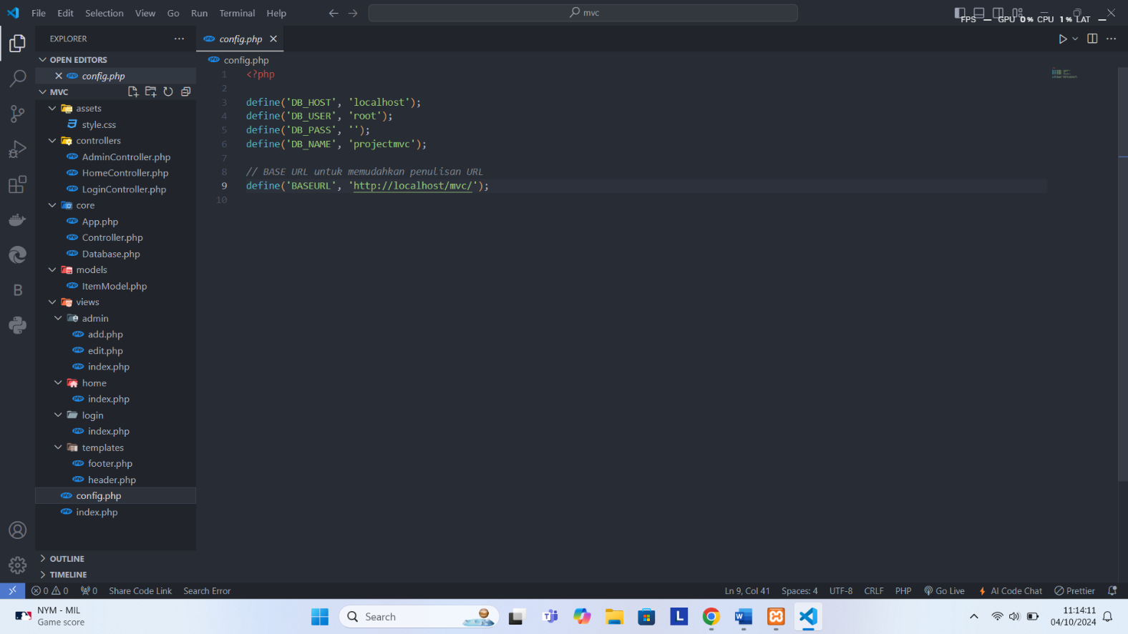Kode config.php

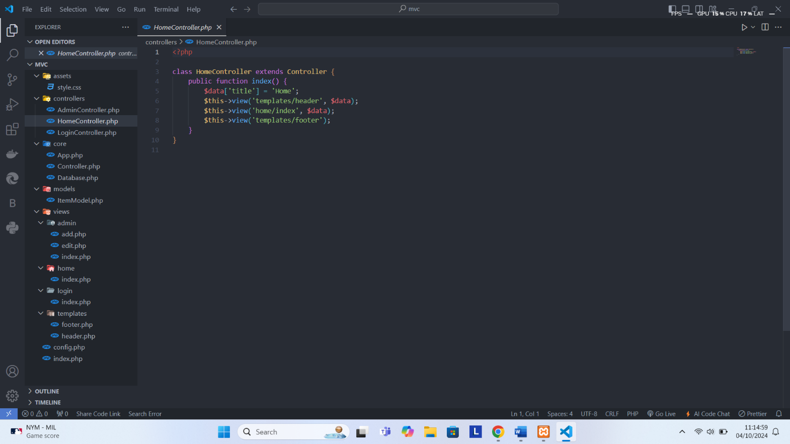Kode controllers/HomeController.php

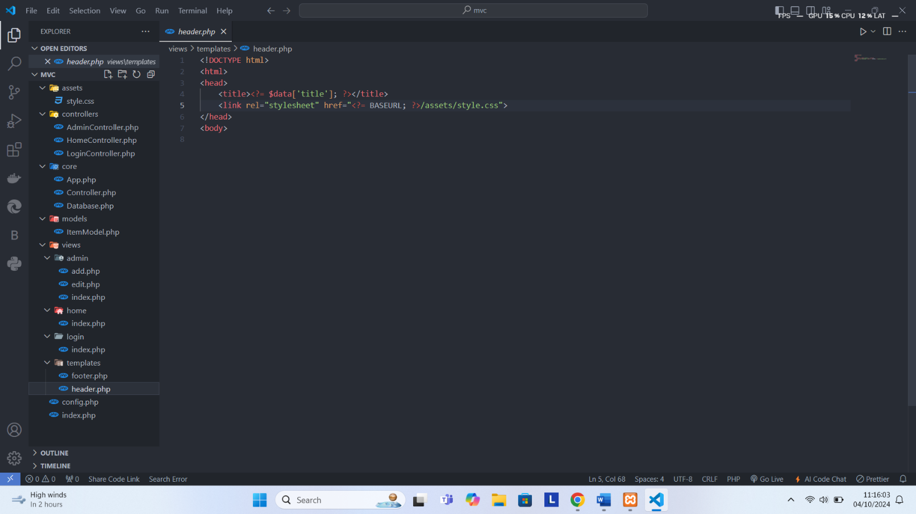Kode templates/header.php

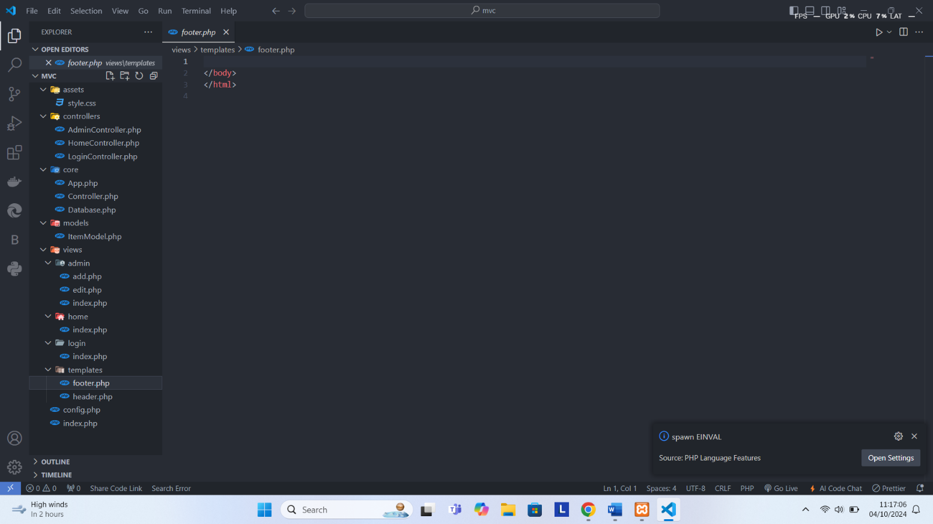Kode templates/footer.php

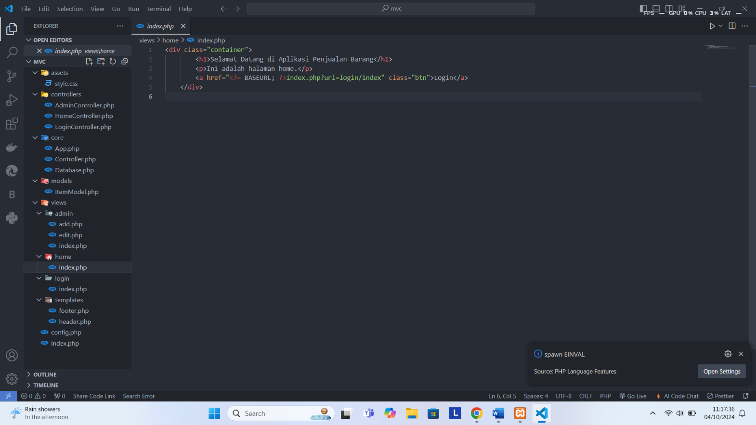Kode home/index.php

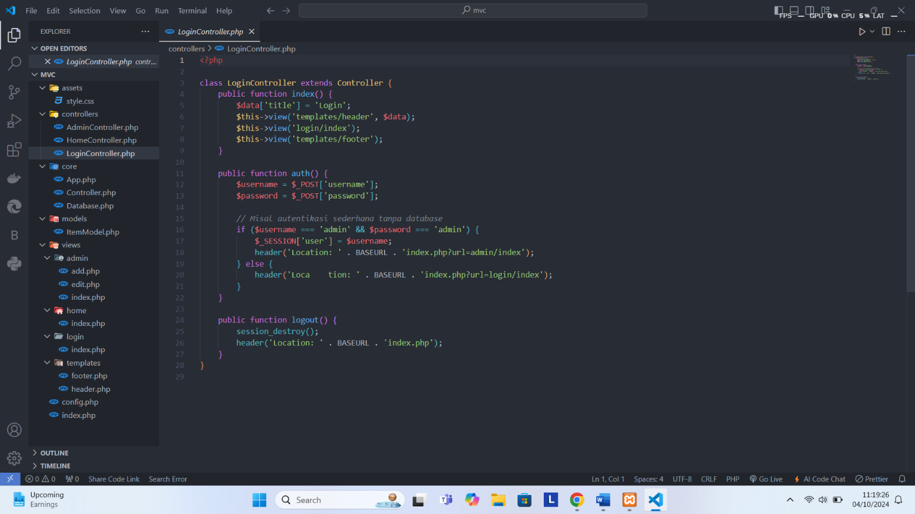Kode controllers/LoginController.php

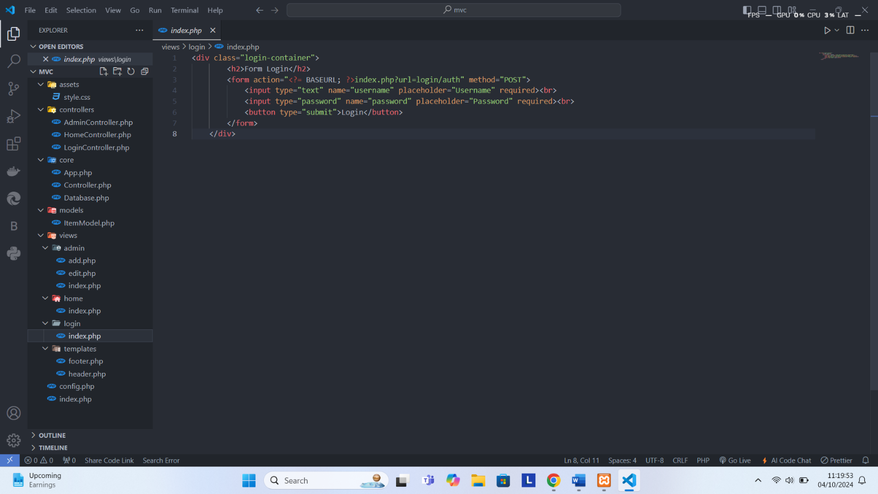Kode views/login/index.php

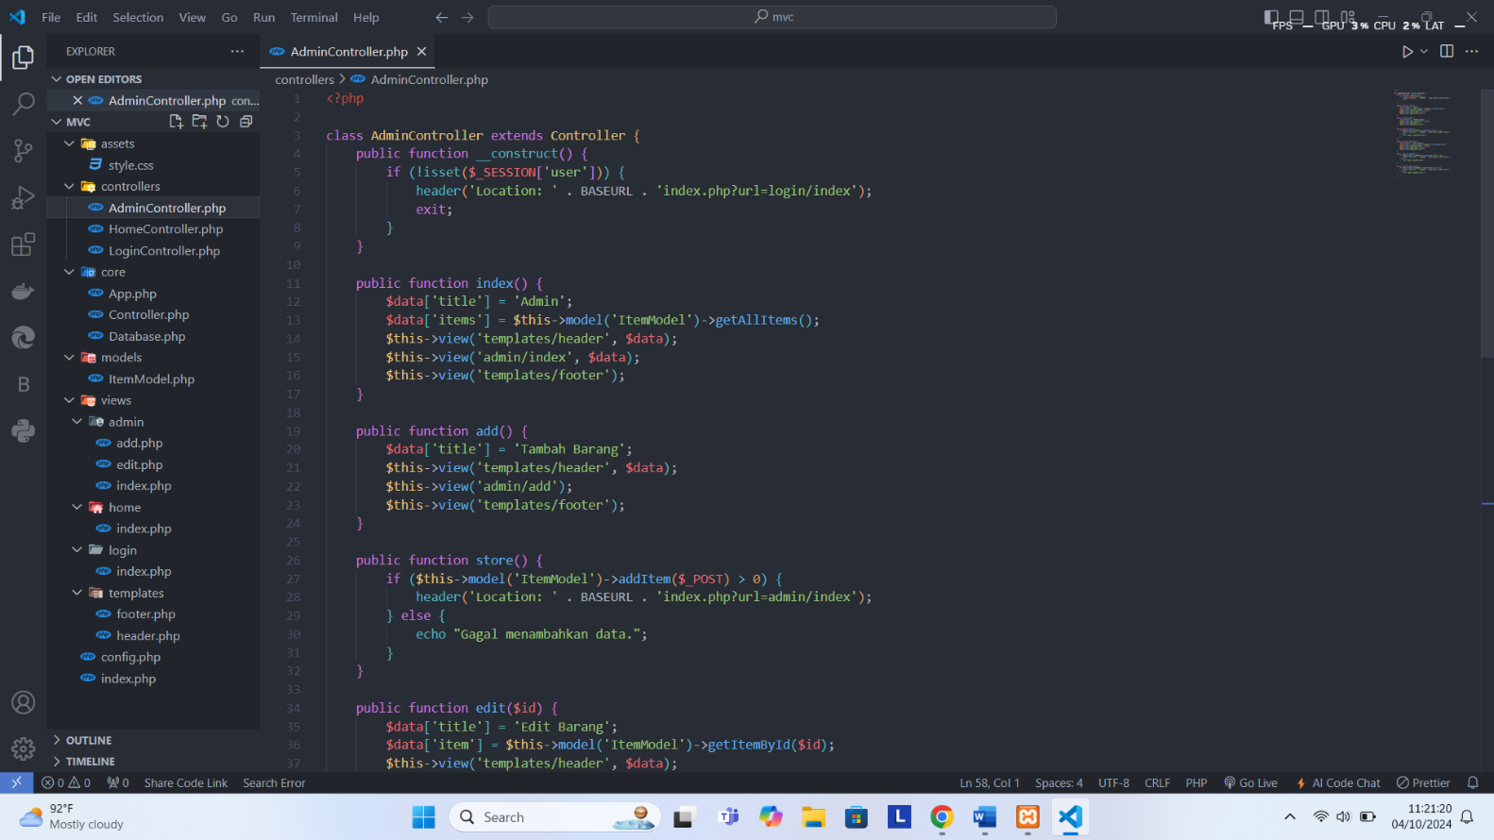Kode controllers/AdminController.php

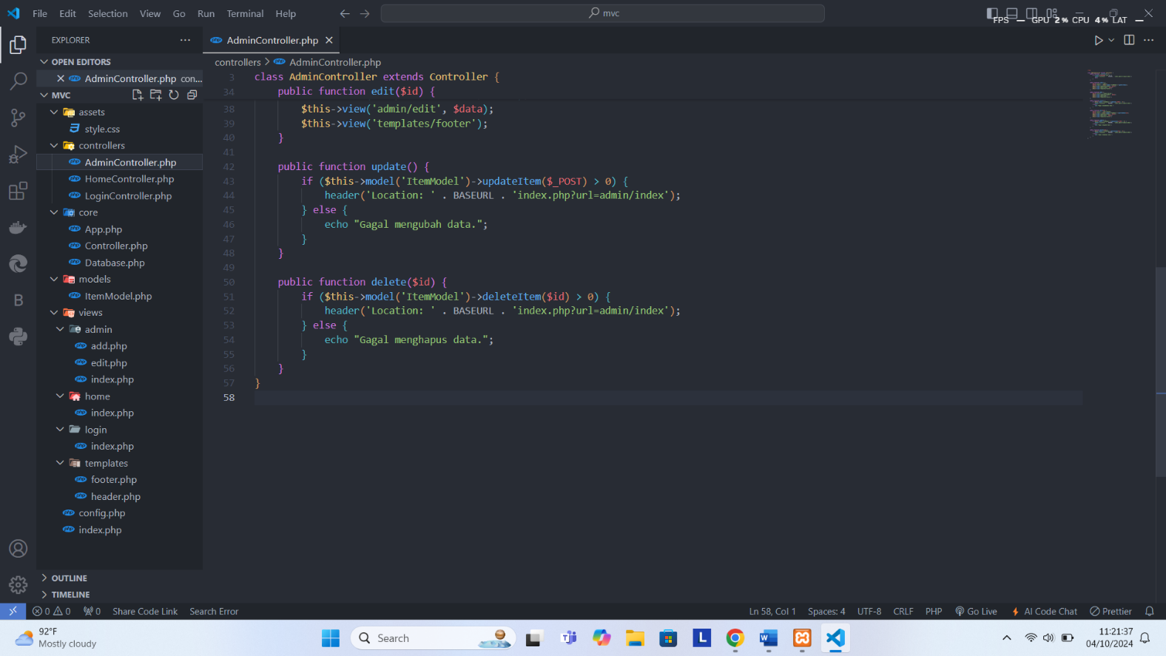

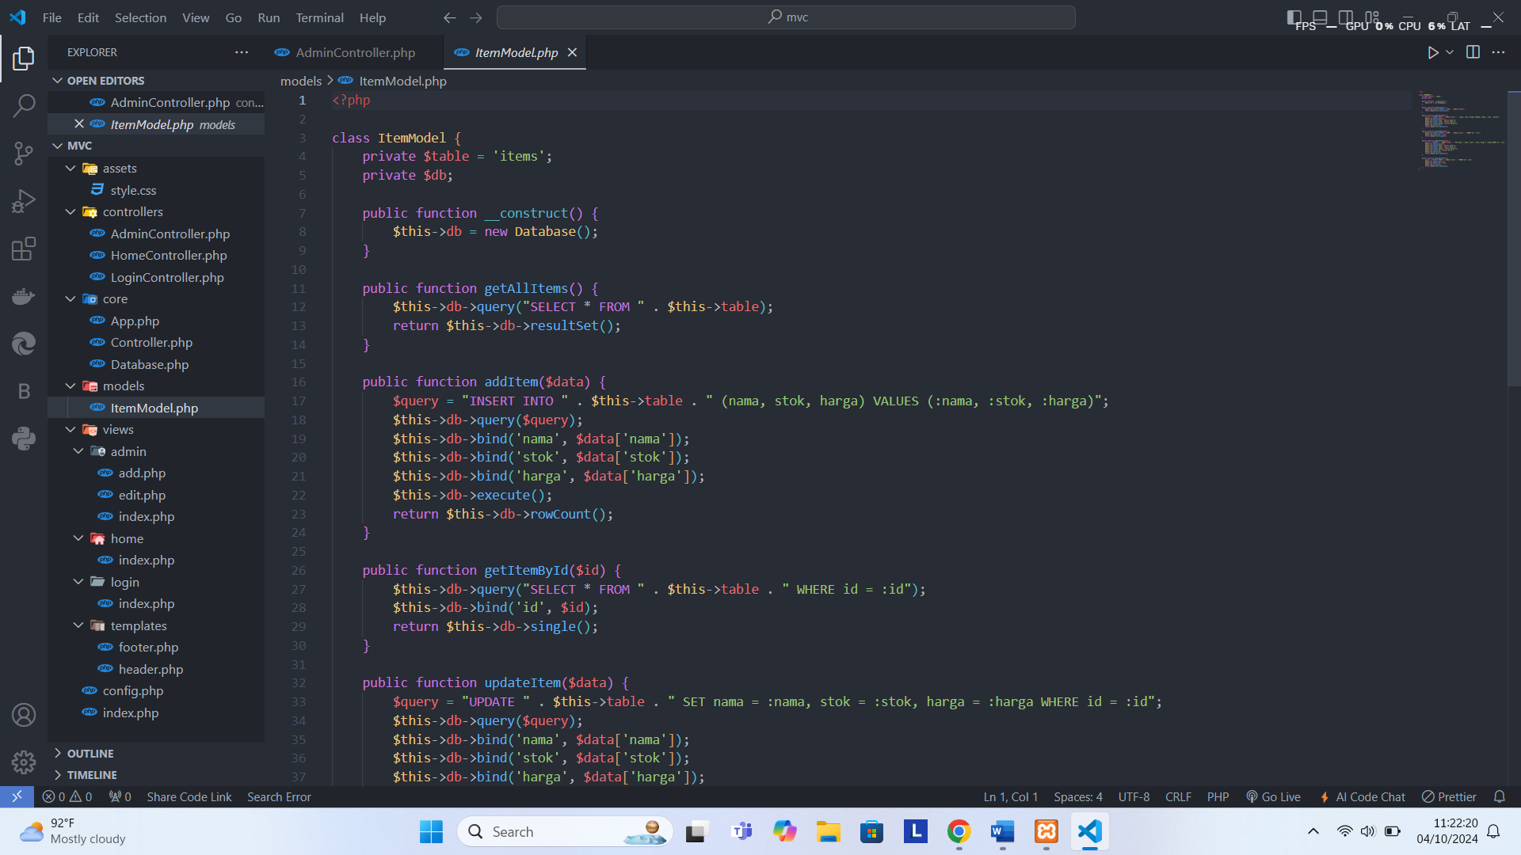Kode models/ItemModel.php

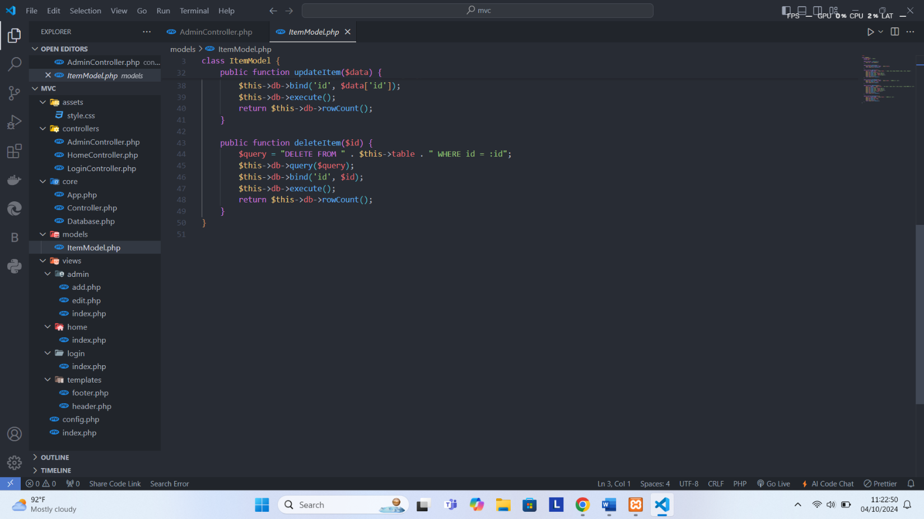

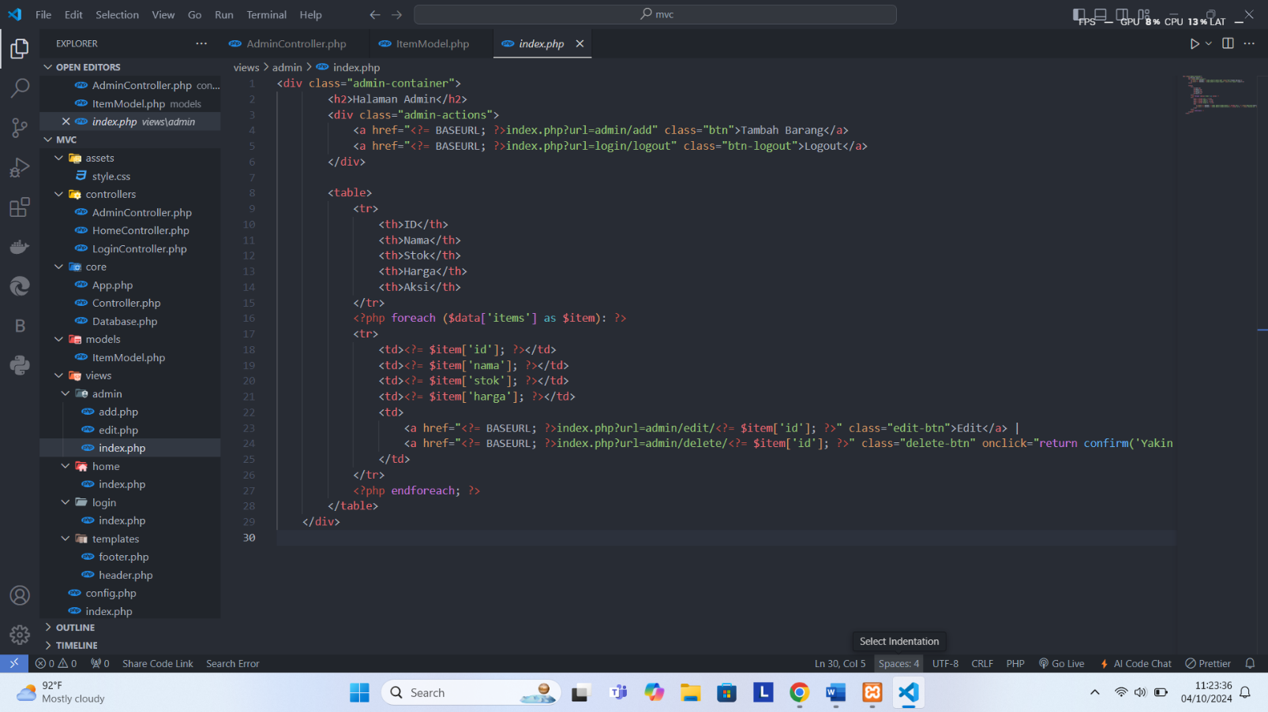Kode views/admin/index.php

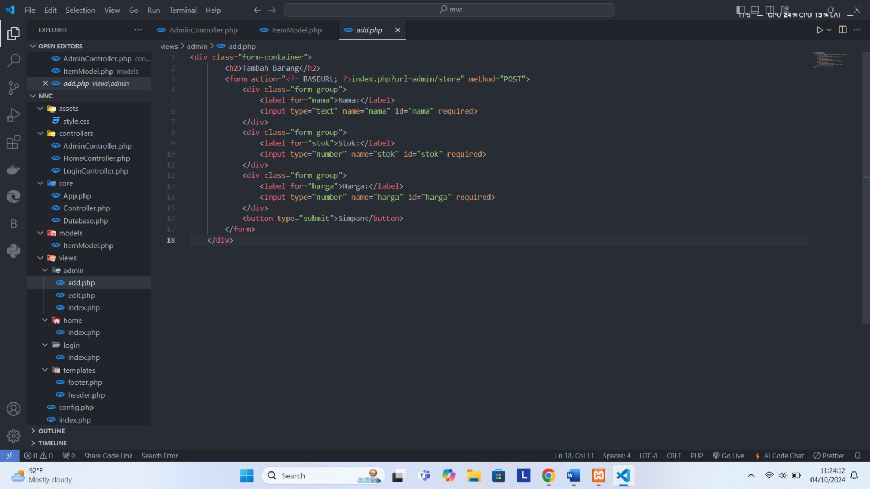Kode views/admin/add.php

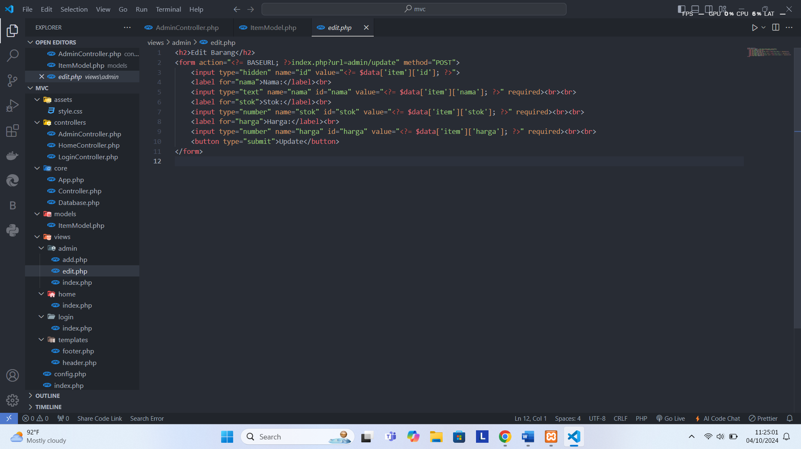Kode views/admin/edit.php

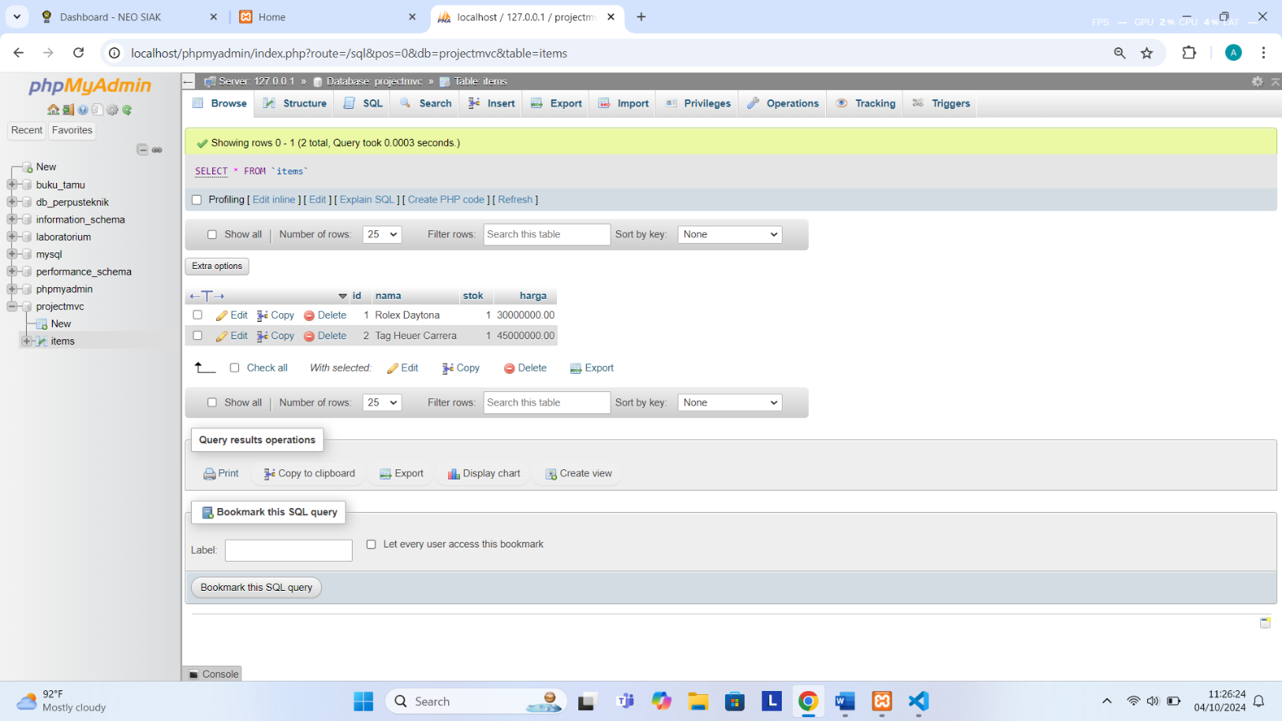Tampilan SQL

Hasil Program

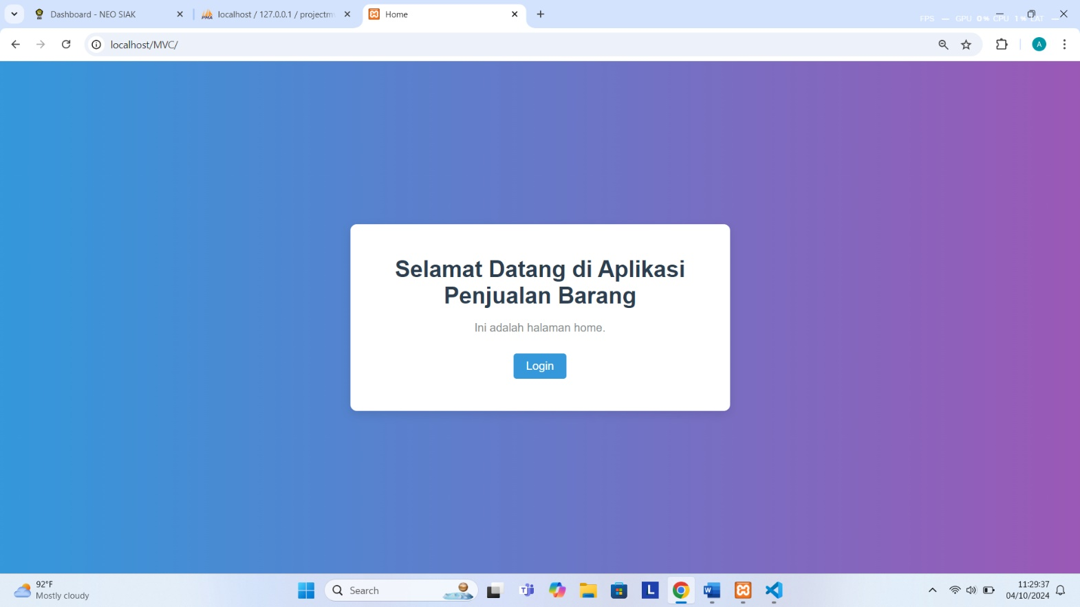*Tampilan Home*

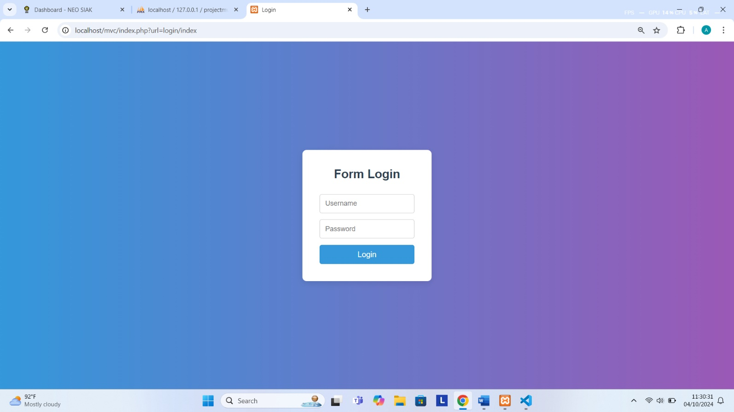*Tampilan Login*

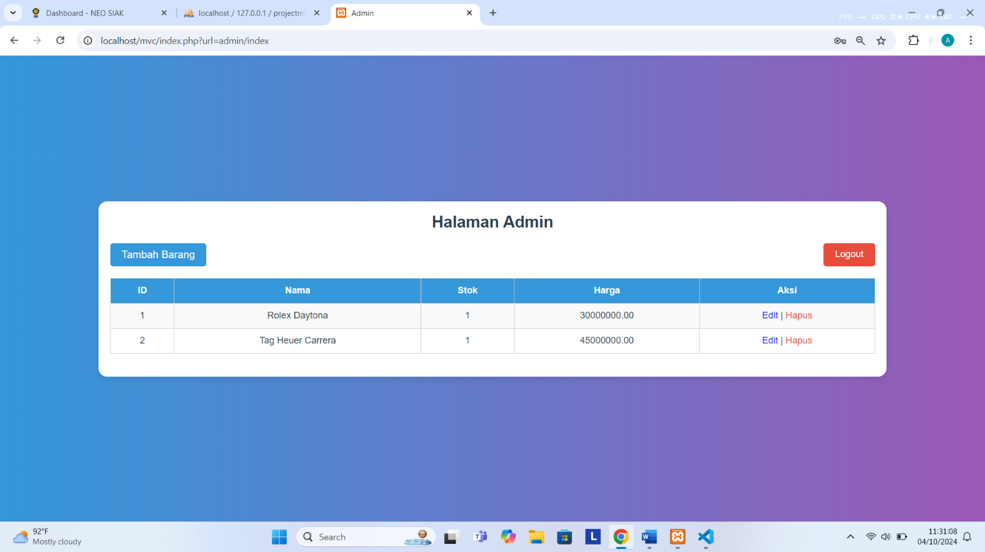*Tampilan Halaman Admin*

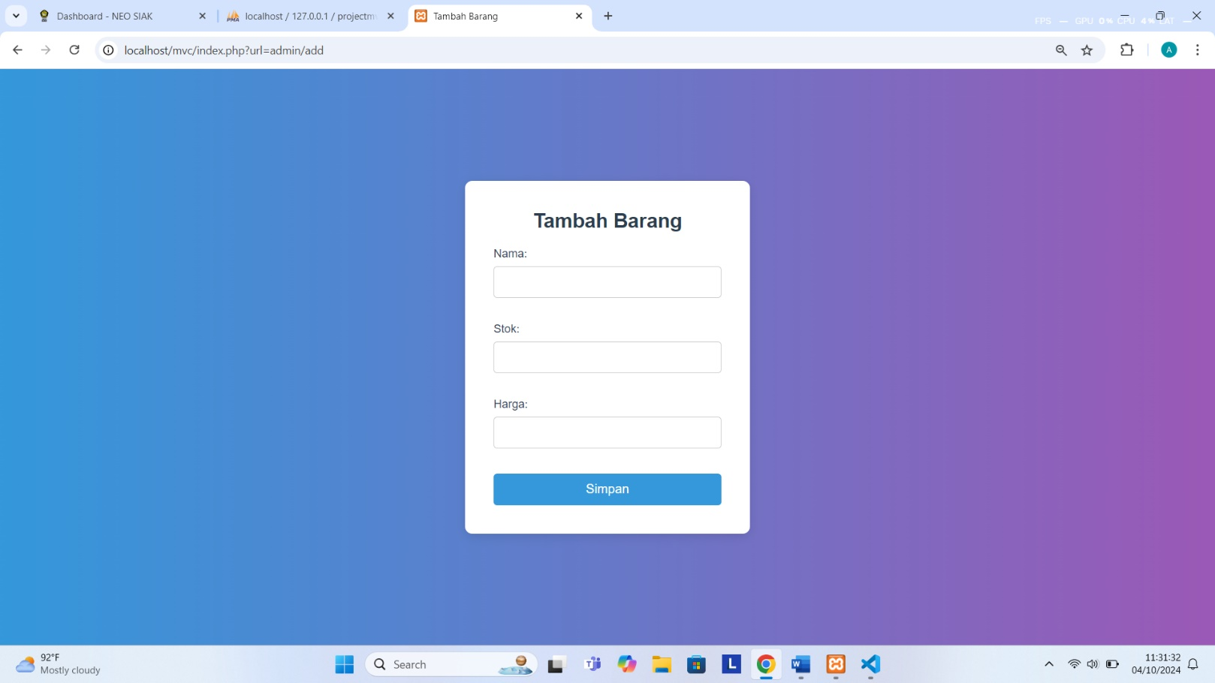*Tampilan Halaman Tambah Barang*

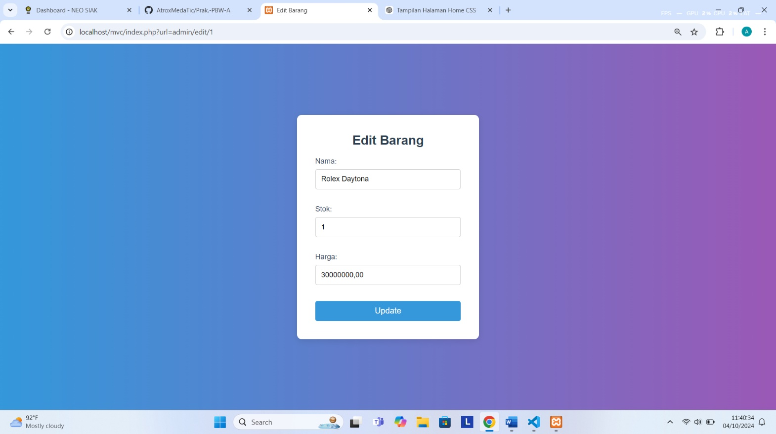*Tampilan Halaman Edit Barang*